FSM State Diagram

Purpose
This document defines the Finite State Machine (FSM) used by the traffic light controller. The FSM determines the traffic light outputs and the conditions for moving from one state to another.

State Definitions
State | Description
S0 | North–South Green, East–West Red
S1 | North–South Yellow, East–West Red
S2 | North–South Red, East–West Green
S3 | North–South Red, East–West Yellow
S4 | Emergency: North–South Green, East–West Red
S5 | Emergency: North–South Red, East–West Green

FSM State Diagram
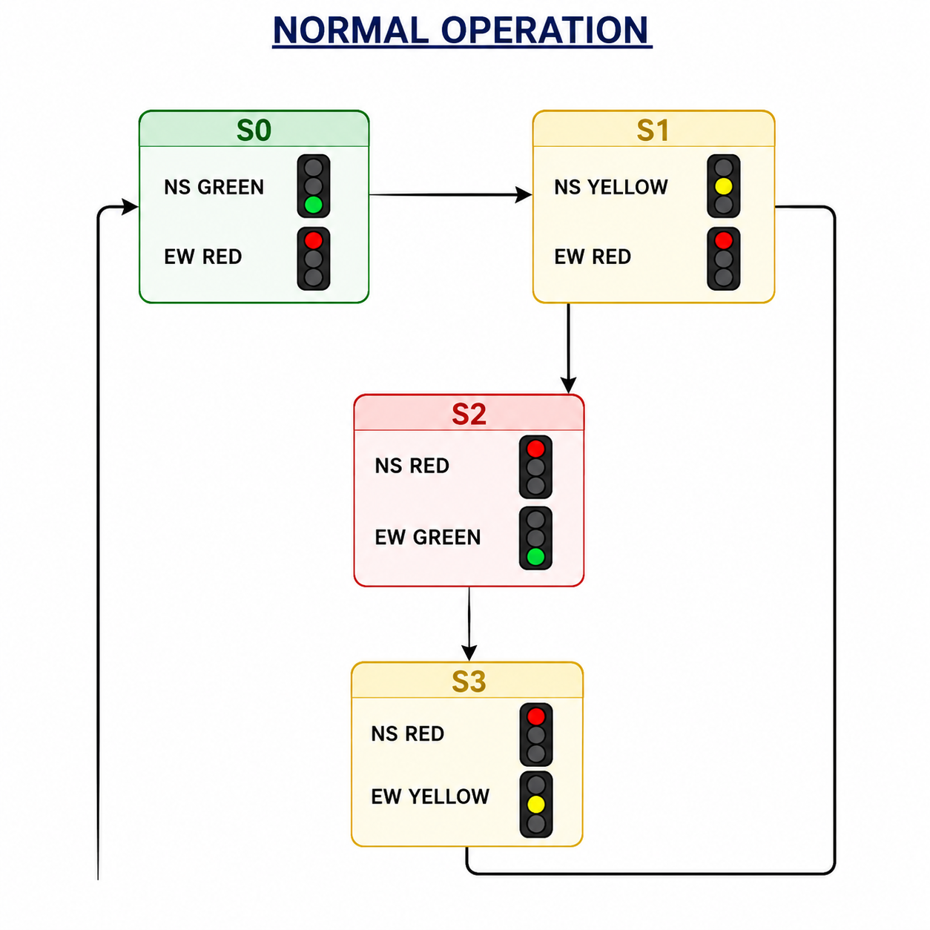
FSM Operation
- After reset, the controller enters S0.
- The timer controls normal state changes.
- If emergency_ns becomes HIGH, the FSM immediately enters S4.
- If emergency_ew becomes HIGH, the FSM immediately enters S5.
- The FSM remains in an emergency state while the corresponding emergency signal stays HIGH.
- When the emergency signal goes LOW, the FSM returns to S0 and resumes the normal sequence.

